Note: Include this page only when adding / amending / deleting a document. If using this document as a record, this Revision History page can be omitted.

REVISION HISTORY

Revision no | Date | Description of Changes | Reason for Revision | Revised by | Approved by
0 | 6 Nov 2017 | New Document | New Document | ARAlacar
TM-BR-MG- 11 Rev02, 10302015

- Objective
To ensure that IT Service Requests are addressed within the agreed target dates.
- Scope
This procedure defines the action and responsibilities of the staff of the IT unit when service requests are reported to the unit. This includes activities from the time a service request is submitted to the department until the time the service request is resolved by the IT staff and subsequently closed by the requestor.
- Definition of Terms
None.

- Procedure Details
RESPONSIBLE | ACTIVITY | INTERFACE
IT Staff | 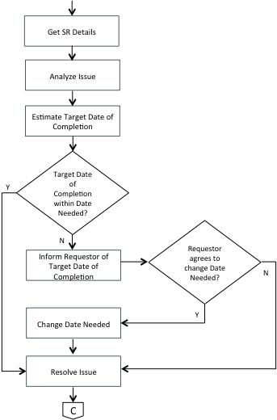  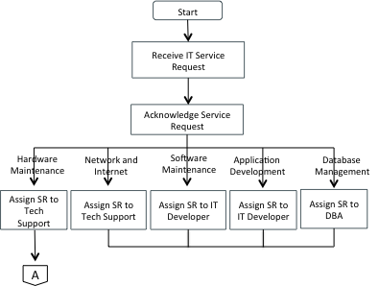 | Requesting Party  Mantis IT SR Ticketing System

RESPONSIBLE | ACTIVITY | INTERFACE
Technical support | 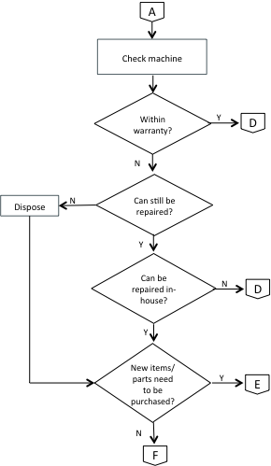 | Machine User manual
RESPONSIBLE | ACTIVITY | INTERFACE
Technical support  Technical Support  Technical Support  Accounts Payable Staff  IT Staff  Requesting Party/ IT Staff | 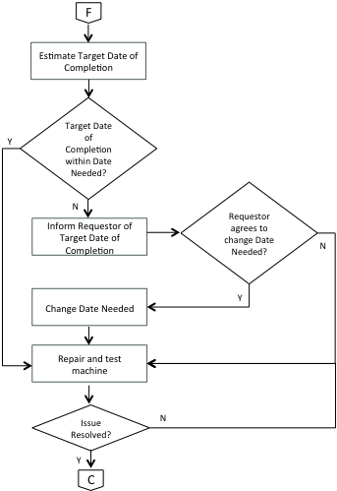  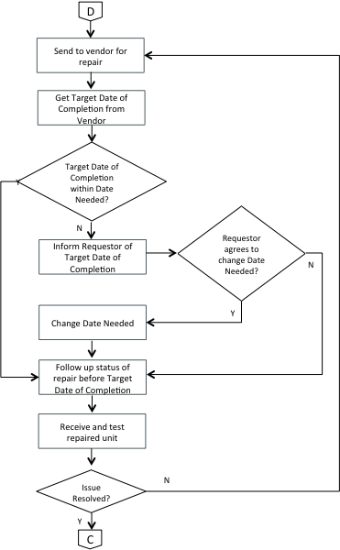  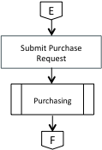  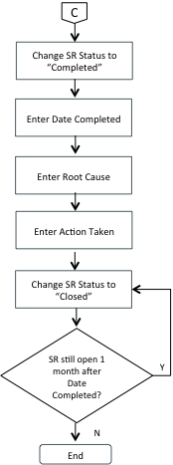 | Requesting Party  Machine supplier/ Authorized Repair Center  Requesting Party  Mantis IT SR  Accounts Payable Staff/  Finance Head  Purchase Request Form  Suppliers  Guidelines for Purchasing  Mantis IT SR System

- References
- Machine User Manuals
- Guidelines for Purchasing

- Quality Records
- IT Service Request
- Purchase Request Form

